52ND FAMILY REUNION REGISTRATION FORM – 2024
JUNE 28th – JUNE 30, 2024

TO: Patrick Busbee DATE: ________________
Fund Administrator
patrickbusbee@gmail.com
FROM: ____________________________________________Phone______________________________
Address: ______________________________________________________________________________
City/State Zip: ____________________________________ E-Mail: _______________________________

I have enclosed $___________ ($300 per adult, $35 children 11-17 years old, $25 children 5- 10 years old and 0 for children 4 and younger. Please reserve _____rooms for me and my family. The following is a list of family members who will be attending.

Make all checks and money orders payable to: Johnson-Barnes Reunion Fund.

ADULTS CHILDREN AGE BOY GIRL
______________________________ ____________________ _____ ____ ____ _______________________________ ____________________ _____ ____ ____ _______________________________ ____________________ _____ ____ ____ ______________________________ ____________________ _____ ____ ____ _______________________________ ____________________ _____ ____ ____

T-SHIRT ORDER
Total: $________

TOURS:
National African American Museum
#______X $20 EACH = $________

NIGHT ON DC TOUR
#______ X $46 EACH = $________

Adults
________Small $15
________Medium $15
________Large $15
________XL $15
________2XL $16
________ 3XL $17
________4 XL $18

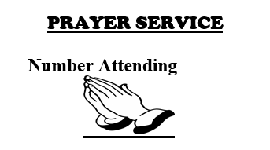

Youth
________Small $12
________Medium $12
________Large $12
________XL $12

Total Amount Sent: $___________
Zelle: johnsonbarnespayments@gmail.com CashApp: $johnsonbarnesfees
PayPal: https://www.paypal.com/paypalme/johnsonbarnespayment

Email : johnsonbarnespayments@gmail.com

RESERVATION DEADLINE MAY 25, 2024
Please Return Form & Check or money order to
Patrick Busbee
14011 Highland Meadow Road
Charlotte, North Carolina 28273
(980) 406-1171 Cell

